
QUALITY ALERT

Customer: Vision Building Products Date: March 1st, 2024
Die: 1147 Colour: Any
Type of Complaint: COMPLAIN

Q.A # Q.I.R # CUSTOMER NCR #

Description: Vision Outdoor COMPLAINED due to material was uneven/ OUT of SPEC.
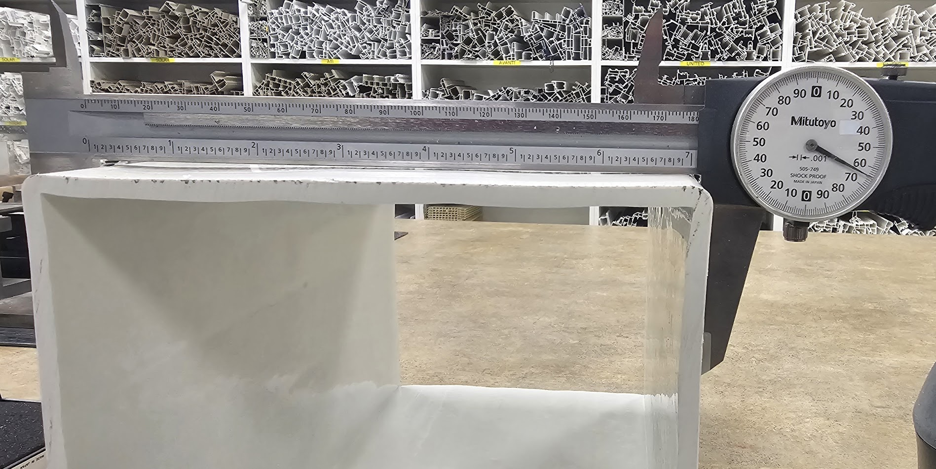

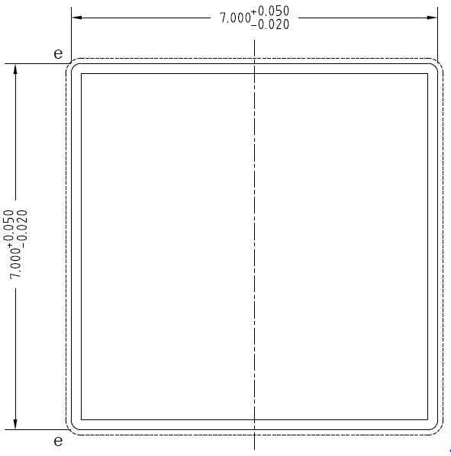

PLEASE MAKE SURE THE DIM IN TOLERANCE
AND 4 SIDES AS FLAT AS POSSIBLE

BY SIGNING BELOW, YOU ACKNOWLEDGE THE PROBLEM ABOVE AND AGREE TO MONITOR THIS ISSUE IN FUTURE PRODUCTION RUNS.
DAY SHIFT |  | AFTERNOON SHIFT |  | NIGHT SHIFT
NAME | SIGNATURE | NAME | SIGNATURE | NAME | SIGNATURE

